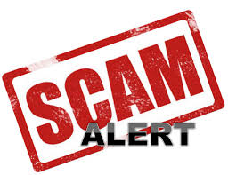

Trading Standard Fact Sheet

Use this factsheet to help protect yourself and stay one step ahead of the scammers

A scam is an illicit scheme to con people out of their money. They can appear by post, phone or email.

- Scams cost the UK economy £5 – 10 billion a year

- 53% of people aged 65 or over have been targeted by a scam

- Only 5% scam victims report the matter

Scams affect the lives of millions of people across the UK. People who are scammed often experience shame and social isolation as a result

Scammers are ruthless predatory criminals, and all kinds of people from all walks of life get duped

They’re very convincing so it’s important to stay vigilant

What are the different types of scams?
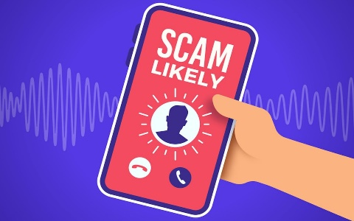
Telephone Scams

Common telephone scams include
investment, pension or computer
support

Phone scams are a common way for criminals to con people out of money

The person calling is often extremely professional and may pretend to be from a trusted organisation such as your bank, the Police or another company
you recognise

The caller may have some
of your information to make them seem genuine

Tips to keep you safe

- Don't reveal personal details. Never give out personal or financial information (such as your bank account details or your PIN) over the phone, even if the caller claims to be from your bank

- Hang up if you feel harassed or intimidated, or if the caller talks over you without giving you a chance to speak, end the call. It may feel rude to hang up on someone, but you have the right not to be pressured into anything

- Ring the organisation. If you're unsure whether the caller is genuine, you can always ring the company or bank they claim to be from. Make sure you find the number yourself and don’t use the one provided by the caller

- Don't be rushed. Scammers will try to rush you into providing your personal details. They may say they have time-limited offer or claim your bank account is at risk if you don't give them the information they need right away

Catalogue Scams

Common types of postal scams include fake lotteries and prize draws, offers of investments, inheritance windfalls, health cures and clairvoyant letters. Scammers send out catalogues selling food, pills, potions, jewellery, clothes or items for your home and garden

They guarantee a prize to those who place an order and make it appear like 'you' are the only one to be getting this amazing offer. They never send the promised prize although some do send inferior goods to keep you interested. Instead they send out more promises to get more orders and more cash from you
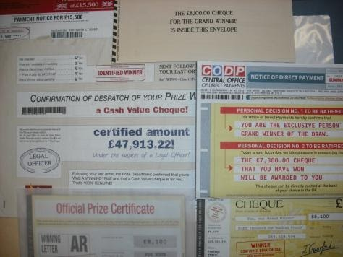

Tips to keep you safe

- Before responding you should always consider whether what’s on offer seems too good to be true. If it does, then it’s likely to be a scam

- Look out for bad spelling or poor grammar

- You’re asked to pay up front to receive what’s on offer – processing or handling fees are a con

Internet Scams
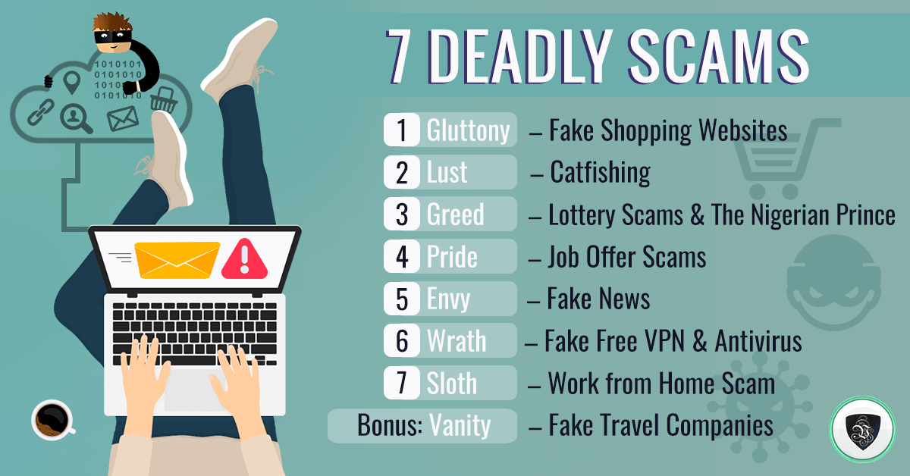

An email may be disguised, to appear to be from your bank or another company in order to trick you into revealing personal details

You may be asked to click on a link which takes you to a fake website where you will be promoted to enter your details
Email scams, also called phishing scams, are becoming increasingly common as fraudsters come up with new tricks to try and steal your personal information and bank details
In some cases the emails have malicious software attached which can infect your computer, tablet or mobile with a virus
Tips to keep you safe

- Be wary of unsolicited messages

- Never give out personal information

- Don't make any advanced payments until you are sure the company you're dealing with is legitimate

- Keep operating system and virus protection software up-to-date

- Make sure all accounts have a strong password

- If you suspect an email might be from a scammer, do not click on any links or download any attachments featured in the scam email as these may download a computer virus onto your computer

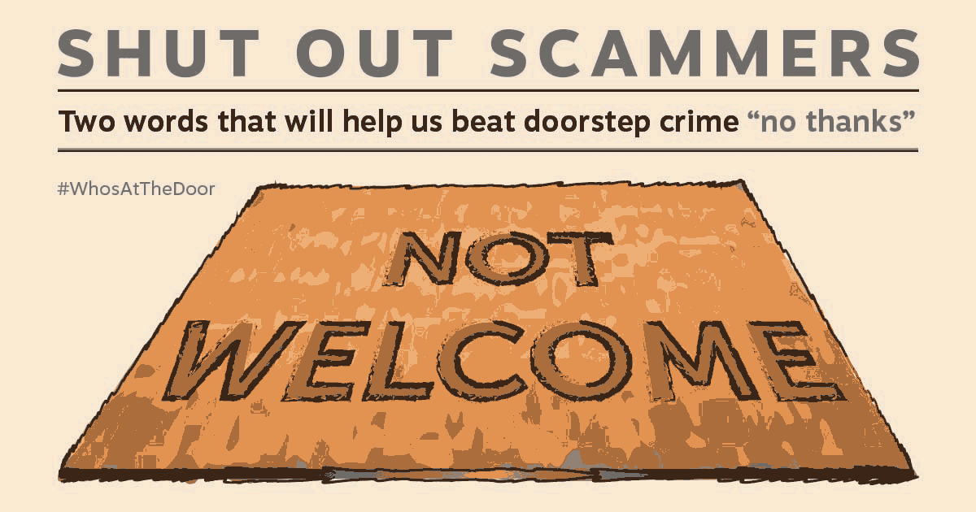
Doorstep Crime

Doorstep criminals are referred to by several different terms:

- Bogus callers - These are people who may use tricks to get you to give them money or personal details

- Rogue traders - These may be offering a service but overcharge you for poor or incomplete work

- Aggressive sellers - In some instances this tactic can constitute a criminal offence

- Distraction burglars - One person may keep you occupied at the front door while another one enters your unsecured home at the back
Tips to help keep you safe

- If you are not sure who is at your door - don’t open it

- Remember to use your door chain if you have to open your front door to strangers

- Always properly check the identity of all callers if they are not known to you before opening your door

- Beware of common tricks such as being asked to make a telephone call, wanting to retrieve a lost ball (even if it is a child) or being asked to check your water, gas or electric. If in doubt keep your door secure

- Always look up telephone numbers for yourself - do not accept numbers provided by callers as they could be bogus

- Always keep doors and windows secure - it is easy for strangers to enter the rear of your home when you are busy answering the front door to their accomplice

- Be suspicious of anyone you do not know. If someone is looking for work or offering services, don’t rush to agree or sign any documents. It is a good idea to seek a second opinion before agreeing to any work

- Ask a friend or neighbour to be available to help you if you need them

How can I protect yourself and others?

Say ‘No’ to unwanted, uninvited callers

If an offer seems too good to be true, it probably is

Don’t feel pressured to make a decision, take your time and seek advice

Be wise to postal scams, no genuine company will ask for money to claim a prize

Keep your personal details safe, always make sure the person you are talking to is genuine and from a legitimate company

Be online savvy, criminals can replicate genuine companies. If you’re unsure, don’t open links or attachments in emails

Talk to someone you trust if you’re suspicious

Anyone can be a scam victim, if you spot a scam always report it

Contact information

If you think you have been scammed, contact your bank first

Report it to Action Fraud on 0300 123 2040 or www.actionfraud.police.uk
to help stop it happening to others

Get advice and report it to Trading Standards through the Citizens Advice consumer service on 0808 223 1133 or online advice at www.adviceguide.org.uk
The Citizens Advice consumer service provides free, confidential and impartial advice on consumer issues
It is important that all complaints are referred to the Citizens Advice consumer service as they maintain a national database of complaints that provides an invaluable source of information and intelligence to the trading standards community
Details of all consumer enquiries, dealt with by the Citizens Advice consumer helpline, are made available to Trading Standards

If you are in immediate danger, contact the police on 999

To learn more about different types of scams and how to protect yourself and others, visit www.FriendsAgainstScams.org.uk and complete the free online training

Why not become a Scam Marshal?

A Scam Marshal is any resident in the UK who has been targeted by a scam and now wants to fight back and take a stand against scams.

Scam Marshals do this by sharing their own experiences, helping others to report and recognise scams and sending any scam mail that they receive to the National Trading Standards Scams Team so that it can be utilised as evidence in future investigative and enforcement work.

Visit www.FriendsAgainstScams.org.uk/ScamMarshals for more information and to sign up

Useful Telephone Numbers

SUTTON COUNCIL | 0208 770 5070
KINGSTON COUNCIL | 0208 547 5000
THAMES WATER | 0800 316 9800
SUTTON AND EAST SURREY WATER | 01737 772000
BRITISH GAS | 0800 072 8625
EDF ENERGY | 0800 269 450
E-ON | 0345 052 0000
NPOWER | 0800 073 3000
POLICE | In an emergency call 999 Textphone 18000
POLICE | Non-emergency 101 Textphone 18001 101
LONDON FIRE BRIGADE | 0208 555 1200 In an emergency dial 999
ACTION FRAUD Fraud Reporting Service | 0300 123 2040 Textphone 0300 123 2050
CITIZENS ADVICE CONSUMER SERVICE | 0808 223 1133
MAILING PREFERENCE SERVICE | 0207 291 3310 or www.mpsonline.org.uk
TELEPHONE PREFERENCE SERVICE | 0207 291 3320 or www.tpsonline.org.uk

