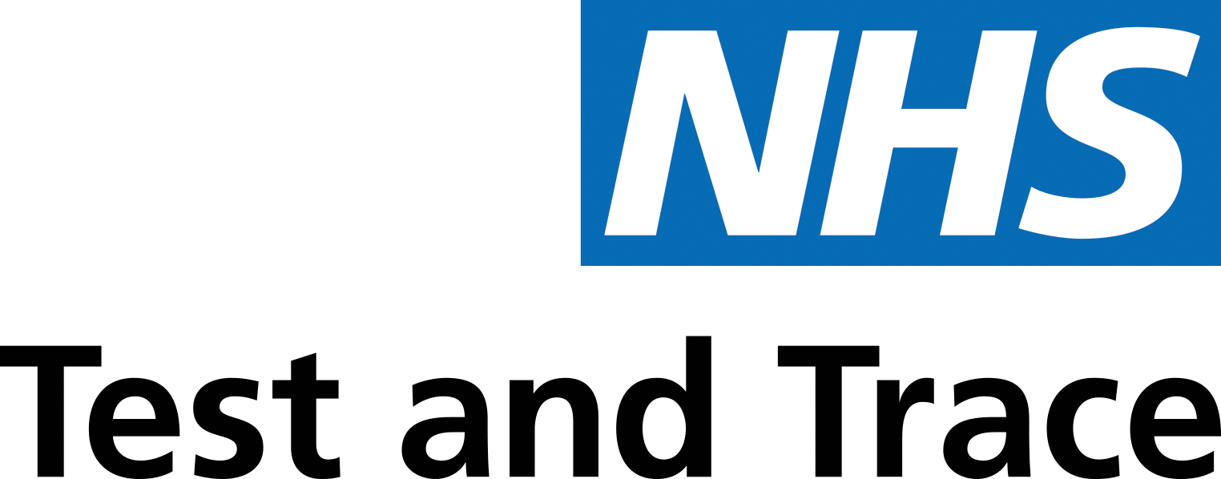
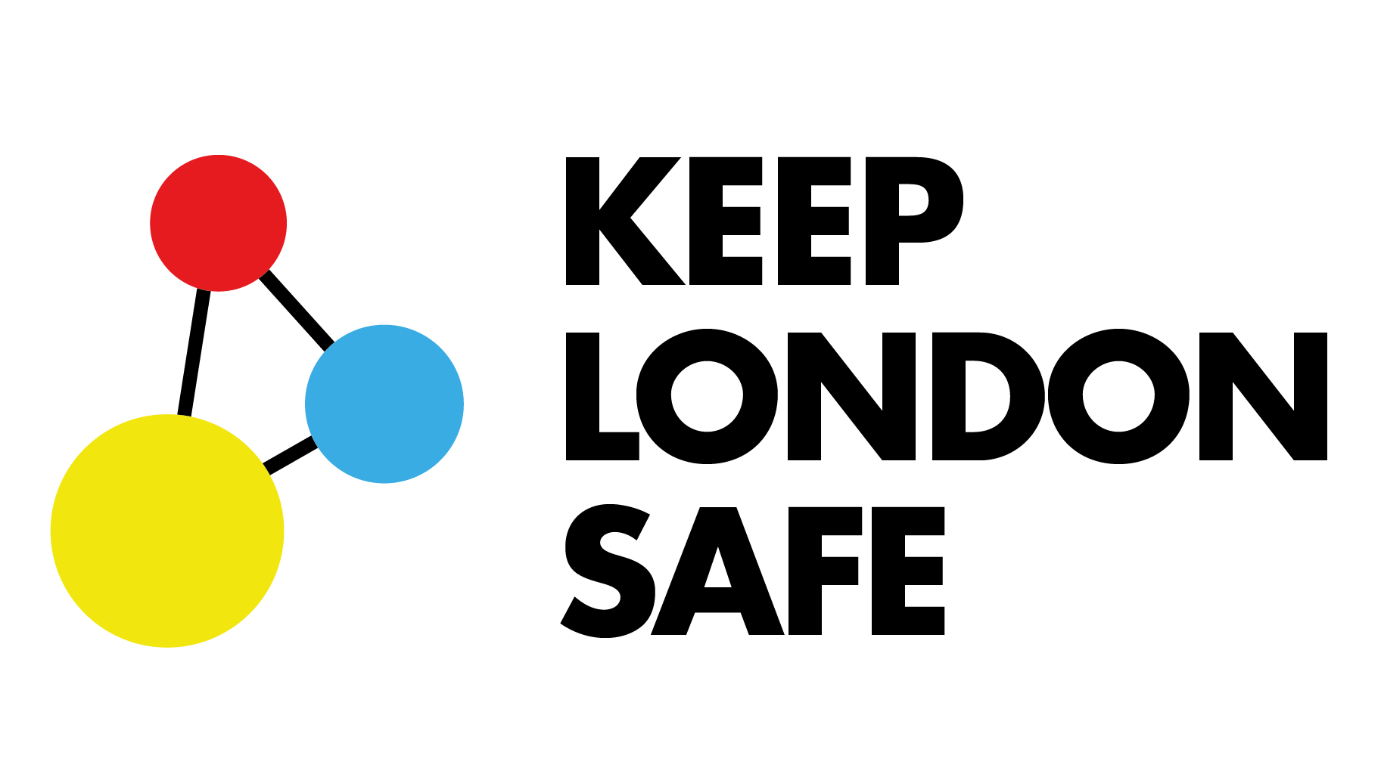

Community Leaders’
Video Toolkit:
NHS Test and Trace
Dear Community Leader

We would like your support to share information about coronavirus testing as part of a London-wide communications & Engagement campaign.

Through Test and Trace, close contacts of those with coronavirus are now being traced as part of a nationwide programme to keep communities safe. If someone is experiencing symptoms of coronavirus they are being asked to take a test to confirm if they have the virus. If this test is positive then the team of contact tracers from the NHS will get in touch with the person and their close contacts and ask them to self isolate for 14 days.

Recent London-wide polling has shown that the level of awareness of how to get a test is very low nationally, but lower amongst people from our BAME communities.

Your role:
Your support in sharing this information through your networks will be very helpful in helping stop the spread of coronavirus and keep our communities safe.

Your contribution can make a real difference and can help save lives in your community. We would like you to film a video on your phone to be shared across social media, including any community WhatsApp groups or online Facebook groups you are part of or aware of. This will help us reach more people, including some who may be misinformed or have fears about coronavirus.

In this pack you will find some essential information to mention in your video, as well as some filming guidance and then assistance in sharing your video. If you work with a community or voluntary organisation that is supporting people who are finding things difficult, please don’t forget to mention how people can access that support.

If possible, please try and keep your video under two minutes. This makes it more likely for people to watch to the end, and also means you can share it on your organisation’s or your own Twitter feed (Twitter only allows you to share videos that are 2 minutes 20 seconds or shorter).

Thanks again for your help. Working together, we can make sure everyone across Kingston borough is aware of how to get a test if they have coronavirus symptoms and the process to follow to keep everyone safe.
In the following pages you will find:
- Key messages to share in your video, as well as more detailed information
- Filming advice to help you film yourself, or to help someone in your household film you
- Advice to help you share your video on WhatsApp and social media
KEY MESSAGES: Test and Trace

Short video message 1 [1 min 30 seconds]
I’m feeling unwell/symptoms

Narrator: Hello, my name is [XX] and I am [INSERT ROLE, OR DESCRIPTION]. I have been asked to share some important messages with
you about what we can all do to help protect our friends and family - and stop
the spread of coronavirus in Kingston.
The main symptoms are:
- a high temperature – this means you feel hot to touch on your chest or back (you do not need to measure your temperature)

- a new, continuous cough – this means coughing a lot for more than an hour, or three or more coughing episodes in 24 hours (if you usually have
a cough, it may be worse than usual)
- a loss or change to your sense of smell or taste – this means you've noticed you cannot smell or taste anything, or things smell or taste different to normal.

Most people with coronavirus have at least one of these symptoms.
If you feel unwell and you think it might be coronavirus[CD3] [IM4] , it is very important that you get yourself tested as soon as possible. Don’t wait. The test will confirm whether or not you have coronavirus and what you need to do next.

There are two ways of getting a test. You can:
- book an appointment at a drive-through or walk-through test site
- ask for a home test kit – this will be delivered to your home
Test sites in Kingston are available now. Please visit
nhs.uk/ask_for_a_coronavirus_test, or call 119 to get a test as soon as possible.
If you get a home test kit, you will need to do the test and return the kit in
the next 48 hours. You will be told how to do this
While you are waiting to be tested and for your results to arrive, you and anyone who lives with you, must stay at home, so that you don’t pass on
any possible infection.
If you aren’t sure whether you have coronavirus, please isolate yourself to stop the spread and get yourself tested immediately. Don’t wait. You are our greatest weapon in the fight against Coronavirus and you can play your part in ensuring
we save lives, protect our friends, family and neighbours and keep Kingston safe for everyone.
Thank you.
OPTIONAL If you have any questions about coronavirus and what we can all do to keep our friends and family safe, please contact [TO BE ADVISED]

Short video message 2 [2 mins]
Contact from Test and Trace Team

Narrator: Hello, my name is [XX] and I am [INSERT ROLE, OR DESCRIPTION].
I have been asked to share some important messages with you about what we can all do to help protect our friends and family - and stop the spread of coronavirus in Kingston.
If you have tested positive for coronavirus, you will be contacted by the NHS Test and Trace Team. This will be by either a text, email alert or a phone call. All information you provide to the NHS Test and Trace service is confidential. No one who is contacted will be told your identity.
The Test and Trace team will need to know who you have been in contact with recently, so that they can check whether or not they have coronavirus. Tracing everyone you may have been in direct contact with is very important in stopping the spread of the virus and protecting your family, friends and neighbours in Kingston.
Even if you have not been feeling unwell and have not been for a test yourself, you might still be contacted by the Test and Trace Team, because you may have recently been in contact with somebody (the team won’t tell you who) that has tested positive for coronavirus.
If this is the case, you will be told to stay at home for 14 days from your last contact with that person. It’s very important that you do this, even if you don’t feel unwell, because you could still be infectious to others. If you don’t have any symptoms of coronavirus, other people you live with won’t need to stay at home, but they must take extra care to follow the guidance on social distancing and handwashing and avoid contact with you at home as much as possible.

If you do develop symptoms of coronavirus, you should immediately book
a test. Don’t wait. The test will confirm whether or not you have coronavirus and what you need to do next. Please contact the NHS online at www.NHS.gov.uk /ask-for-a-coronavirus-test, or you can call 119 to arrange a test as soon as possible. Test sites in Kingston are available now.
Even if your test is negative, it is very important that you still complete your 14-day self-isolation period, because the virus may not be detectable yet - this is crucial to avoid unknowingly spreading the virus.
Self-isolation stops the spread of coronavirus. This means that you should not leave your home for any reason – If you need food or medicine, please try to order it online, or by phone, or ask a friend or family member to drop it off at your home. And if you need assistance with food, medicine or anything else, help is available from Kingston Council and other agencies. Please visit www.connectedkingston.uk, call us on 020 8547 5000 to find out more, or complete the support form at www.bitly.com/KingstonHelp

You are our greatest weapon in the fight against coronavirus and you can play your part in ensuring we save lives, protect our friends, family and neighbours - and keep Kingston safe for everyone.
Thank you.
OPTIONAL If you have any questions about coronavirus and what we can all
do to keep our friends and family safe, please contact [TO BE ADVISED]

Short video message 3 [2 mins]
I’ve been contacted by the Test and Trace Team, but I live with my family,
what should I do?
Narrator: Hello, my name is [XX] and I am [INSERT ROLE, OR DESCRIPTION].
I have been asked to share some important messages with you about what we can
all do to help stop the spread of coronavirus in Kingston.
If you are contacted by the Test and Trace Team because you may have been in contact with someone who has coronavirus, you will be told to stay at home for
14 days from your last contact with that person. The team won’t tell you who
you may have in been in contact with, because that information is confidential,
but it’s very important that you self-isolate if contacted to prevent the risk of
spreading the virus.
This means that you should not leave your home for any reason – so if you
need food or medicine, please try to order it online, or by phone, or ask a friend
or family member to drop it off at your home. And if you need assistance with food, medicine or anything else, help is available from Kingston Council and other agencies. Please visit www.connectedkingston.uk, call us on 020 8547 5000 to find out more, or complete the support form at www.bitly.com/KingstonHelp

If you don’t have any symptoms of coronavirus yourself, other people in your household won’t need to self-isolate with you, but they must take extra care to follow the guidance on social distancing and handwashing and avoid contact with
you at home as much as possible.

If you have any symptoms of coronavirus, the Test and Trace Team will arrange for you to get a test. While waiting for the test and the result, you should stay at home
for at least 7 days - and any friends or family who live with you will need to self-isolate for 14 days from when you first began to feel ill (this is because people can have the virus for up to 14 days without realising, so they could unintentionally infect others).
There are a number of things you can do to protect each other
while you self-isolate together
If you can:
- stay on your own in one room as much as possible and keep the door closed
- avoid using shared spaces (such as the kitchen) at the same time as
other people – eat your meals in your room if possible
- use a separate bathroom if that’s possible - otherwise, use the bathroom
after everyone else and clean it each time you use it, for example, by
wiping the surfaces you've touched

You can also reduce the spread of infection in your home with
a few simple Dos and Don’ts:
Do
- wash your hands with soap and water often, for at least 20 seconds
- cover your mouth and nose with a tissue or your sleeve (not your hands) when you cough or sneeze
- put used tissues in the bin immediately and wash your hands afterwards
- clean objects and surfaces you touch often (such as door handles, kettles and phones) using your regular cleaning products
- consider wearing a face covering when in shared space such as the living room or kitchen
- keep windows open in the room you're staying in and shared spaces as much as possible
Don't
- share towels, including hand towels and tea towels
You are our greatest weapon in the fight against coronavirus and you can play your part in ensuring we save lives, protect our friends, family and neighbours - and keep Kingston safe for everyone.
Thank you.

OPTIONAL If you have any questions about coronavirus and what we can all do to keep our friends and family safe, please contact [TO BE ADVISED]
Filming advice

This will help you film a video on your phone.

Setting up
- To film this video you will need a smartphone.
- Please check your lighting and background – make sure it isn’t interfering with the picture, and that there’s enough contrast.
- If you can, film somewhere quiet and without too much background noise.
- If you can, please try to avoid wearing clothes with big logos, brands or messages on them, as it might be distracting.

Filming
- If you have someone in your household who can film you, ask them to film you in landscape mode.
- If you’re filming yourself and you’d like to film in landscape mode, try and prop your phone up against something stable.
- Otherwise it’s fine to do a handheld ‘selfie’ video using your front-facing camera.
- If you can, film the video in one take – it’s absolutely fine to have a few
slip-ups and pauses, and actually makes it look more authentic.
- Try and speak clearly and not too fast, and to look directly at your phone
or tablet while you record.
- If you can, try and keep the video reasonably short – ideally under two minutes.

Technical guidance

- To record a video on your phone or tablet, open the Camera app and switch to Video mode, then tap the Record button to start and finish recording.
- The video will automatically be saved to your camera roll or photos section of your phone.
- Video in one take – it’s absolutely fine to have a few slip-ups and pauses, and actually makes it look more authentic.
- Try and speak clearly and not too fast, and to look directly at your phone
or tablet while you record.
- If you can, try and keep the video reasonably short – ideally under two Minutes.

How to share your video

WhatsApp
If you are in any community WhatsApp groups, please share this video
with these groups.
- Open the WhatsApp group.
- Click the ‘+’ to the left of where you type your message, and select
‘Photo & Video Library.’
- Select the video you would like to share, and click ‘Send’.
- You can do this in multiple groups.

How to share your video

Twitter
- If your organisation has a Twitter account, you can also share the video
on Twitter.
- You can tap the Tweet icon to upload a video.
- Below the Tweet compose box, you’ll see quick selection options to add
a new video. Your most recent videos from your gallery will appear as thumbnail

If you can use the hashtag #keepLondonsafe, this will mean that
we can see it and share it as well.

