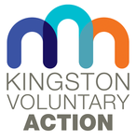

Findings and actions from the
‘Community Action in Kingston’ summit

May 2021

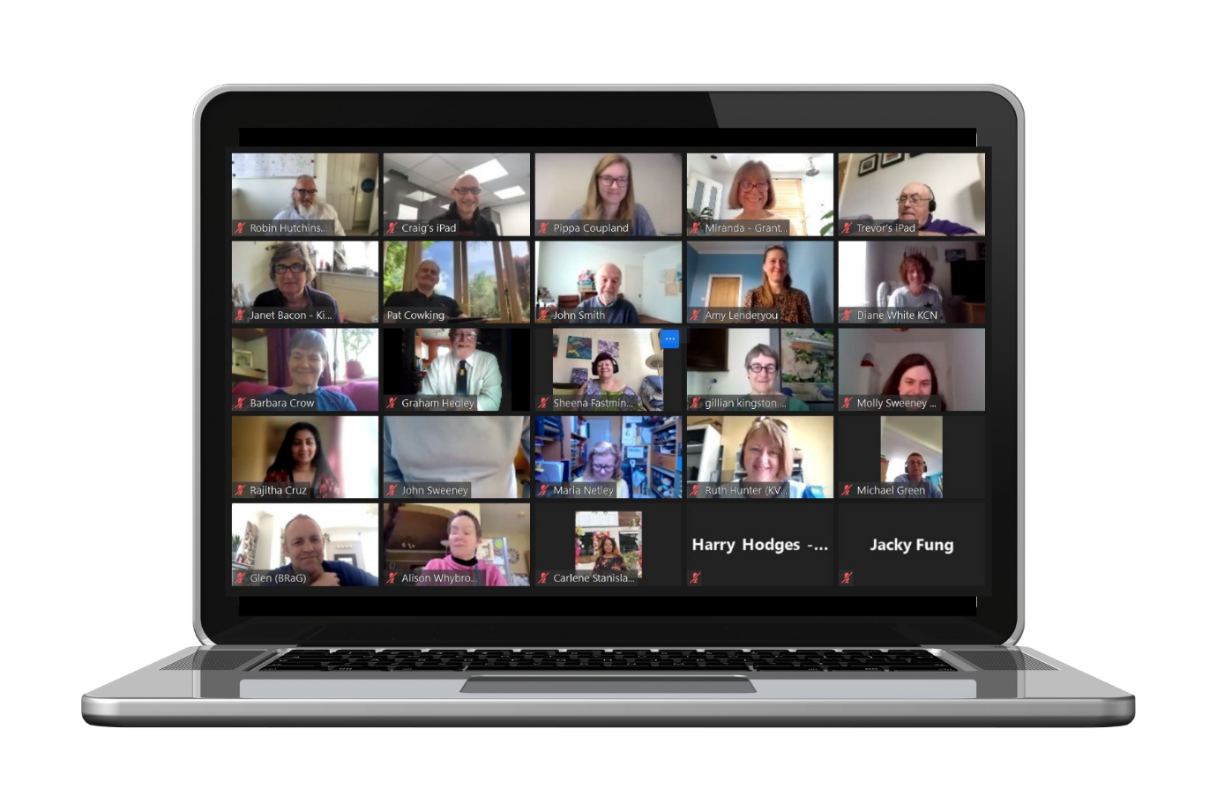
Contents

Section | Page
Summary | 3
Introduction | 3
The Community Action in Kingston event | 4
Findings from workshops | 6
Findings from survey of needs | 9
Support offered and actions since the conference | 10
Evaluation of event | 11
Appendix – links to resources | 12

Summary

This report is based on the findings, and survey responses, from the Community Action in Kingston event that took place on 19 May 2021.
The event was organised by Kingston Voluntary Action on behalf of the Volunteering and Volunteer Experience Working Group (Communities Task Force).
The event was a great success, and provided inspiration for participants who were able to celebrate the achievements of the past year.
The most valuable part of the event for us was listening to those who have been involved in helping the community during Covid, and learning what support is needed for community action to continue to thrive.

Introduction

In 2020, Covid-19 changed the lives of everyone in Kingston. Amidst the confusion, worry and insecurity, communities stepped forward to support their neighbours and fellow residents.

On 19 May 2021, over 60 participants joined us at the Community Action in Kingston event, for the chance to learn from the period of volunteering and community action during the pandemic, and celebrate what has been achieved.

At this event, the Leader and CEO of Kingston Council, Kingston councillors, Kingston Voluntary Action and Volunteering Kingston said thank you to all those Kingston residents who engaged in informal volunteering during the pandemic to ensure that those in most need were looked after.

We also heard from the community about their needs, both existing and newly identified, and about the things people in Kingston are passionate about. Attendees also told us about the challenges they have faced, and what support they need to continue being engaged.

It was clear from the feedback received that those who attended wanted to stay connected, talk to each other, and help Kingston through the post-Covid challenges, as we begin to emerge from lockdown.

The Community Action in Kingston event
The event was a great success and provided inspiration for participants who were able to celebrate the achievements of the past year.

Community Action in Kingston event agenda:

- Welcome by Sanja Djeric-Kane, CEO Kingston Voluntary Action

- ‘Thank You’ from Caroline Kerr (Leader of Kingston Council) and Ian Thomas (CEO of Kingston Council)
Video: https://youtu.be/wIg7YIbS-64

- Community Action during Covid-19 - Molly Sweeney, Volunteering Kingston.
Presentation: https://kva.org.uk/assets/documents/volunteering-kingston

- From community choir to soup kitchen of Kingston in one (Covid) year - Pippa Coupland, Voices of Hope.
Presentation: https://kva.org.uk/kvanew/a/45134370-45142834

- Connected Kingston video, and Q&A with Antoine Al Hosri (Kingston Council).
Video: https://youtu.be/vPewavCDVqA

- Making Kingston: Places for the Future - Robin Hutchinson, Community Brain
Presentation: https://kva.org.uk/assets/documents/community-brain

- Questions and answers

At the event we listened to three inspiring presentations. Molly Sweeney from Volunteering Kingston talked about Kingston’s amazing volunteering efforts throughout the pandemic, Pippa Coupland from Voices of Hope told us about their agile move from a newly established charity to a Kingston soup kitchen, and Robin Hutchinson from Community Brain wowed us all with his plans to transform the borough of Kingston into a place where we can all have fun again.

The most valuable part of the event for us was listening to those who have been involved in helping the community during Covid and learning what support is needed for community action to continue to thrive. More about that in the next section.
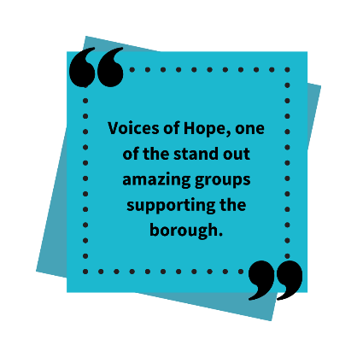 | 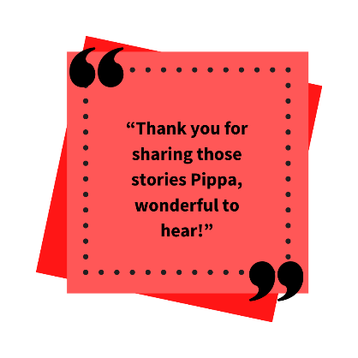
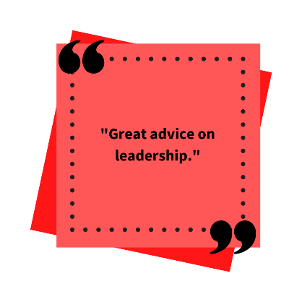  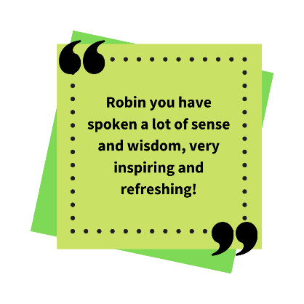 | 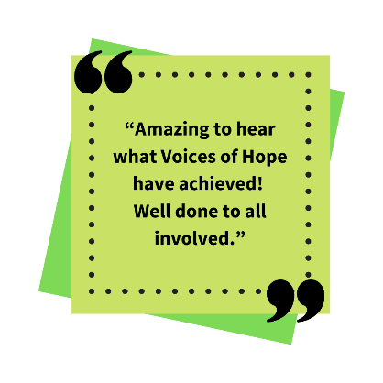  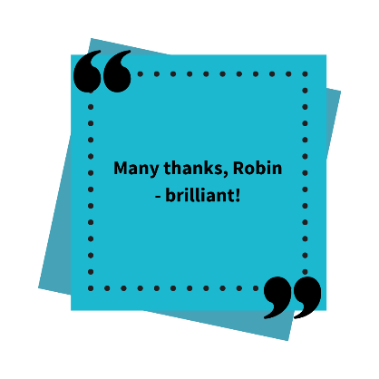
Findings from workshops

There were four workshop questions that we explored with the participants:

- Have you identified any other needs in your locality while you have been volunteering?

- Have you got an idea/passion that you would like others in your locality to get involved in?

- What are the barriers preventing you from addressing this need, or developing your idea with others?

- What support do you need?

Below are the key themes and responses to these workshop questions.

- Have you identified any other needs in your locality while you have been volunteering?
Theme | Participant response
Mental health and wellbeing | What I found during the choir project this year was that there are a lot of people suffering with hidden anxiety issues who had a tendency to ''hide'. We need to be able to identify these people much sooner in an unthreatening way.
Access to services, support and technology | For many people who use technology e.g. phones etc. communication is fine, but for those who do not use technology, getting the message out is difficult. Could there be a central hub for those people?
Places to meet | We need meeting places or ‘Bump Spaces’ where social interaction can take place and ideas can be supported.
Community/Building networks of support | We need to help people reconnect with others post-lockdown; and help people recover emotionally and economically from the consequences of the pandemic and lockdown.
Access to green spaces/Environmental Action | We need Green areas around Kingston that volunteers can join together to create environmental safe spaces for all to enjoy.

2. Have you got an idea/passion that you would like others in your locality to get involved in?
Theme | Participant response
Environmental action & sustainability | Grow more food. Find or start a community garden. Defend green spaces. Repair projects of various kinds - less throwing away, more upcycling and re-using.  Build community environment networks.
Mental health support | Encourage intergenerational links (e.g. younger with elderly isolating individuals).  Continue Befriending/buddy schemes. I think a positive scheme during lockdown was phoning the elderly. The befriending call made such a difference as family couldn’t visit and social centres were closed. Would love this to continue via social services?  Mental Health is going to be an ongoing growing concern. Quick access to services is needed, maybe a buddying scheme/ a phone call check in with someone can help.
Making resources accessible to the community | An idea I am pursuing is inclusive social cafes. Everyone is welcome; everything is free. People can pool their personal assets and social capital, and help each other.

3. What are the barriers preventing you from addressing this need, or developing your idea with others?
Theme | Participant response
Lack of resources/funding | Lack of staff resources - the wait for services for mental health support via the system is too long. People are in desperate need, and just getting through to services is a massive task.
Lack of time & volunteers | Furloughed workers are returning to work, and we are losing an army of volunteers.
Lack of access to venues | Lack of meeting places to share ideas, resources and skills.
Lack of training & capacity | Lack of capacity and skills needed to ensure the continuity of various projects.
Reaching people in need & creating networks | Overcoming people's reluctance to seek help/know where it might be found.
4. What support do you need?
Theme | Participant response
Training, Funding & Advice | Learning all the ropes about setting up a charity.
Collaboration & Networking | Collaboration opportunities. We can bring specific academic knowledge, add capacity and offer unique insights from talented young people. We need partners to engage with!
Finding venues | We need premises. A large space that could be used by various organisations to undertake work, offer storage etc. There are lots of empty premises in Kingston and rents are too high to be viable for small organisations, and for the types of community organisations we have been reliant on during Covid.
Promotion | We need more awareness of what is available. Small charities need greater promotion so that people know about them.
Finding staff & volunteers | As the furlough scheme comes to an end, we need to keep diversifying the volunteer cohort.

Findings from survey of needs

To get more granular information about the support needed by participants, we asked them to complete an online form in which we outlined the various types of assistance available from Kingston Council (RBK), Kingston Voluntary Action (KVA), Volunteering Kingston (VK) and the Kingston Charitable Foundation (KCF). An overview of the results, showing the particular support or information requested by participants, is shown in the graph below.

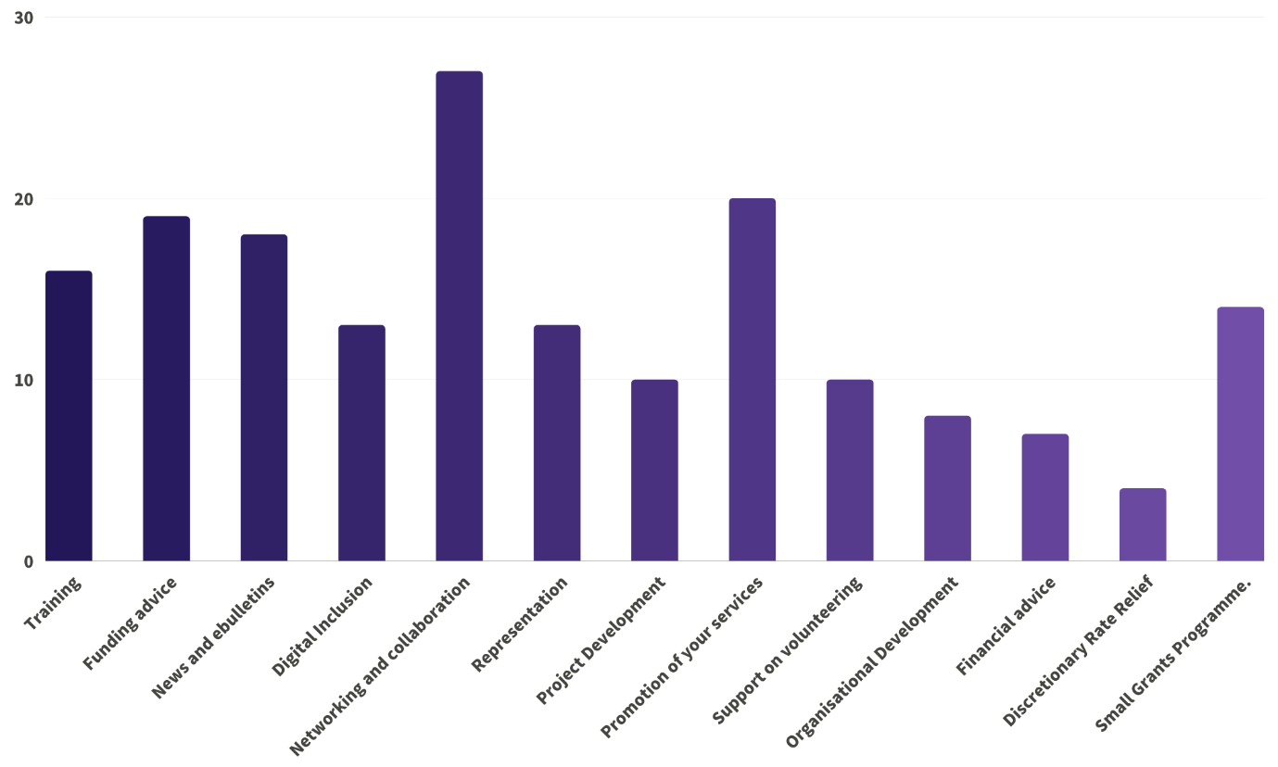

 | Theme – in order of popularity | No. (out of 30)
 | Networking and collaboration | 27
 | Promotion of your services | 20
 | Funding advice | 19
 | News and e-bulletins | 18
 | Training | 16
 | Small Grants Programme. | 14
 | Representation | 13
 | Digital Inclusion | 13
 | Support on volunteering | 10
 | Project Development | 10
 | Organisational Development | 8
 | Financial advice | 7
 | Discretionary Rate Relief | 4

Support offered and actions since the conference

In addition to the feedback we received on support needs, we continue to collate information about the support needs of the community and the actions we have taken since the conference.

You can read more here about how we are responding to requests for support.

Thanks

Many thanks to the presenters at the event:

- Cllr Caroline Kerr, the Leader of Kingston Council

- Ian Thomas, Chief Executive of Kingston Council

- Molly Sweeney, Volunteering Kingston

- Pippa Coupland, Voices of Hope

- Robin Hutchinson, the Community Brain

Evaluation of the event
At the end of the event, participants were invited to share their feedback about the event itself, through an online form, and also let us know any further thoughts they had about the topics discussed at the conference. The feedback was very positive.

Summary of evaluation findings

- The majority of attendees found the event to be accessible and relevant.

- The average score on how useful participants found the event was 4.27 out of 5.

- In response to questions on whether participants would like more regular network meetings for informal community groups, 100% of respondents said ‘yes’.

- The most popular frequency for these network meetings was quarterly meetings.

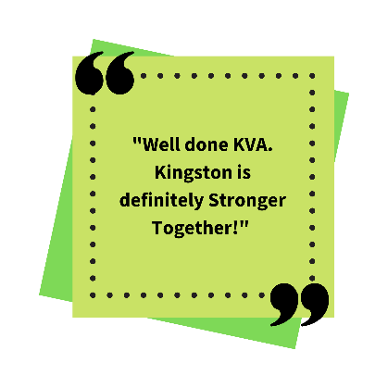 | 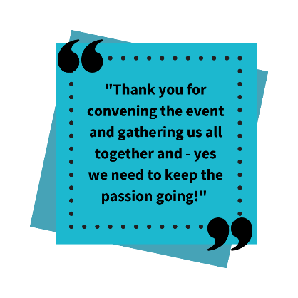 | 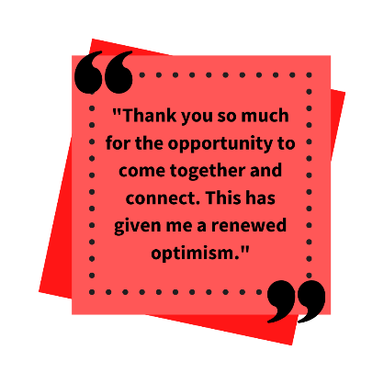
 | 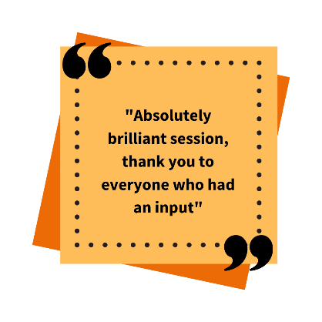 | 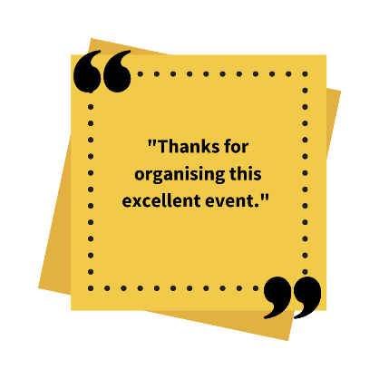

Appendix

Links below to resources shared at the event

Kingston Hospital’s ‘Thank You’ video
https://youtu.be/JVN2th9M-kI
‘Thank You’ from Caroline Kerr (Leader of Kingston Council) and Ian Thomas (CEO of Kingston Council)
https://youtu.be/wIg7YIbS-64
‘Community Action during Covid-19’ presentation
Molly Sweeney, Volunteer Brokerage Co-ordinator, Volunteering Kingston
https://kva.org.uk/assets/documents/volunteering-kingston
‘From Community Choir to Soup Kitchen of Kingston in one (Covid) year’ presentation
Pippa Coupland, Voices of Hope
https://kva.org.uk/kvanew/a/45134370-45142834
Connected Kingston video
https://youtu.be/vPewavCDVqA
‘Making Kingston: Places for the Future’ presentation
Robin Hutchinson, Community Brain
https://kva.org.uk/assets/documents/community-brain

