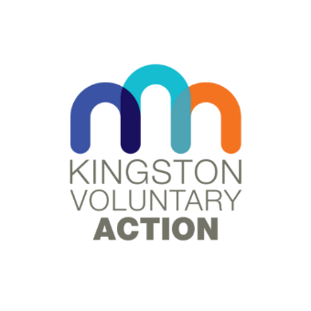
Kingston Voluntary Action is looking for a VCSE (Voluntary, Community and Social Enterprise) Sector Development Manager
Salary: £42,500 + 5% pension contribution for a full-time post (35 hours per week)

Kingston Voluntary Action (KVA) is a long-established and well-respected infrastructure support organisation for the voluntary and community sector in Kingston. We have grown in the last few years in the number and variety of projects as well as the number of team members. KVA is in its first year of delivering the Infrastructure Support Contract awarded by the Royal Borough of Kingston. We are now looking for a proactive, solution focused manager with experience in supporting VCSE organisations to establish, develop and lead the KVA Organisation Development Service. This service will offer an ambitious and innovative capacity building programme for Kingston’s VCSE sector. You will provide strategic leadership for VSCE Organisation Development Service in collaboration with the existing internal KVA team and external experts, including KVA’s established ‘Ask the Expert’ programme. We are looking for the right candidate to be both a dynamic leader for the service and also contribute effectively to the KVA’s Senior Leadership Team.
KVA is an expanding, ambitious team with a great working culture. We offer 27 days of annual leave, plus Bank Holidays, salary sacrifice scheme and hybrid working.
Application pack which can be found here: https://kva.org.uk/jobs/ and consists of:
- Job Description and Person Specification and
- Job Application and Equal Opportunities Monitoring Form (CVs will not be considered)
Please give a concise statement as part of the Application. This should include details of relevant experience and your reasons for applying for this post based on the person specification.
The completed and signed application should be sent to Sanja.djerickane@kva.org.uk and copied to sue.doherty@kva.org.uk. You can also post the completed application to: Sue Doherty, Kingston Voluntary Action, Siddeley House, 50 Canbury Park Road, Kingston KT2 6LX. Should you have any questions about the role, please ring Sanja Djeric Kane on 0208 255 3335.
Closing Date: Monday, 29th January 2024, midday
Notification of an interview: Thursday, 1 February 2024
(Please note, if you have not heard from us on 1 February, this means that on this occasion you have not been selected for an interview)
Interviews: Tuesday, 13 February 2024

