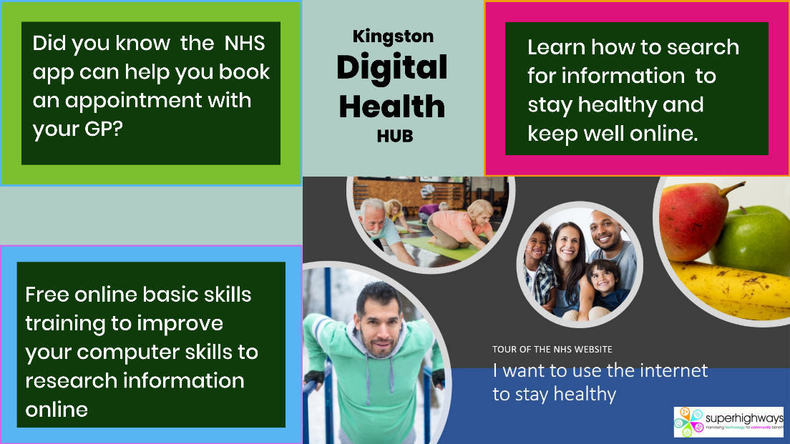
Kingston Digital Health Hub is a community-based training project run by Superhighways. We help improve the digital skills of residents to
- Research reputable health information sites – like the NHS website
- Use online transactions like booking a GP appointment booking online
- Access their medical records via the NHS app.
There are three ways for you to refer residents, clients and even family to the project
1. Using Connected Kingston
You can refer anyone who lives in Kingston to the Kingston Digital Health Hub through Connected Kingston. We will follow up with a chat to find out what they want to learn. We can offer up three one to one training sessions. These are currently delivered via zoom or a video call. Link https://www.connectedkingston.uk/services/kingston-digital-health-hubs
2 - Email or phone referral
Contact Philippa Leary – 020 8255 8040 email philippaleary@superhighways.org.uk
3 - Group presentation NEW
Recently we started delivering a one-hour session focusing on exploring the NHS website with questions and answers. These informal health sessions are going, and you are welcome to contact us to arrange a session. Our aim after each session is to offer one to one skills training and get everyone to try one course on the Learnmyway online learning platform.

