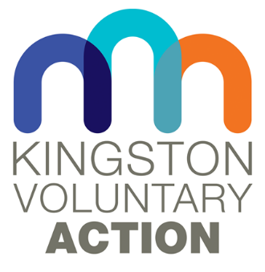

Before returning this form please ensure that the service user knows about the scheme and is happy to be referred.

Once completed return to:

Kathryn Smith, Go Kingston Volunteering, Siddeley House, 50 Canbury Park Road, Kingston-upon-Thames, Surrey, KT2 6LX tel: 0208 255 8068/8685
Email: buddyscheme@kva.org.uk

Service User Details
Name: | Date of Birth:
Address:

Telephone:
Email:
Care Manager (if applicable): | Contact No.:

Details of Person Referring
Name:
Address:

Telephone:
Email:
Relationship to Service User:

Primary Supporter’s / Carer’s Details
Name:
Address:

Telephone:
Email:
Relationship to Service User:
Service User’s Personal Details

Please complete with as much detail as possible. If any of the following are unknown to you, please state, as these can be followed up. Details of any risk assessment or guidelines should be included.

Diagnosis

Medical Needs

Name and Address of GP Practice (optional)

Mental Health Needs (please include details of any challenging behaviour)

Mobility (wheelchair user, possibility of falls etc)

Safety Issues (including road safety awareness)

Personal Care Needs (any assistance needed with toileting, etc.)

Communication Skills (speech, level of understanding, etc.)

Leisure Interests / Favourite Activities

Could the service user make arrangements to see a volunteer independently?

Does the service user have the ability to handle money independently?

Availability (When would the service-user like to go out with their buddy?)

Other Issues (relating to the service user having a buddy)

Next of Kin and Contact Number

Data Protection

We use the information provided to find the most appropriate volunteer for each service user. We will pass on relevant information to volunteers, once they are matched with a buddy.

All information is stored securely and is only accessed by Buddy Scheme staff.
Once a service user has left the scheme we will delete all the personal information we hold on them.

Signed ……………………………………..

Date ……………………………………….

MONITORING FORM

We are asked by our funders, the Royal Borough of Kingston upon Thames, to provide information on the service users of the Buddy Scheme. This is to ensure that we are reaching as many people as possible in the borough.
Please could you provide the following information. You do not have to fill in this form, and choosing not to fill it in will make no difference to you getting a buddy.
What is your Ethnic Origin?
White English/Welsh/Scottish/  Northern Irish/British |  | Indian
White Irish |  | Pakistani
Gypsy or Irish Traveller |  | Chinese
Any Other White Background |  | Korean
Black English/Welsh/Scottish/  Northern Irish/British |  | Tamil
Caribbean |  | Bangladeshi
African |  | Other Asian Background
Any other Black Background |  | Arab
White & Black Caribbean |  | Any Other ethnic group
White & Black African |  | Prefer not to say
White & Asian
Other Mixed Background

What is your Religion?
Christian |  | Buddhist
Hindu |  | Jewish
Muslim |  | Sikh
Other Region |  | No Religion
Prefer not to say

Which of the following best describes how you think of yourself?

Heterosexual |  | Bisexual
Gay |  | Other – please tell us
Lesbian |  | Prefer not to say

Are you happy for us to share this information with Royal Borough of Kingston Council?
Yes No

